HIKE, BACKPACK & URBAN WALK LEADER APPLICATION
If you are interested in volunteering as a hike, backpack, or urban walk trip leader, fill out this form and we will forward it to the nearest volunteer committee so they can review it and help you begin the process of familiarizing you with our guidelines, policies, and standards for these activities. Generally, all prospective hike, backpack, and urban walk leaders should attend a new leader seminar and do a mentored trip in addition to filling out the application at this link.

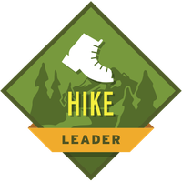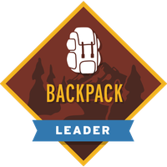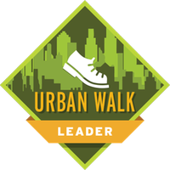
The look on people's faces when you get them outside and show them places they've never seen is one of the best rewards for volunteering. If you are interested in contributing to the mission of The Mountaineers by organizing and leading hikes, backpacking trips, and urban walks, please let us know by completing this simple application. Our committees vet new leaders to ensure everyone meets our activity standards, and this application provides relevant information about your goals and experience. One of our volunteers will follow up with you on the next steps to get you certified as a hike, backpack, or urban walk leader!
Thank you for your interest!

